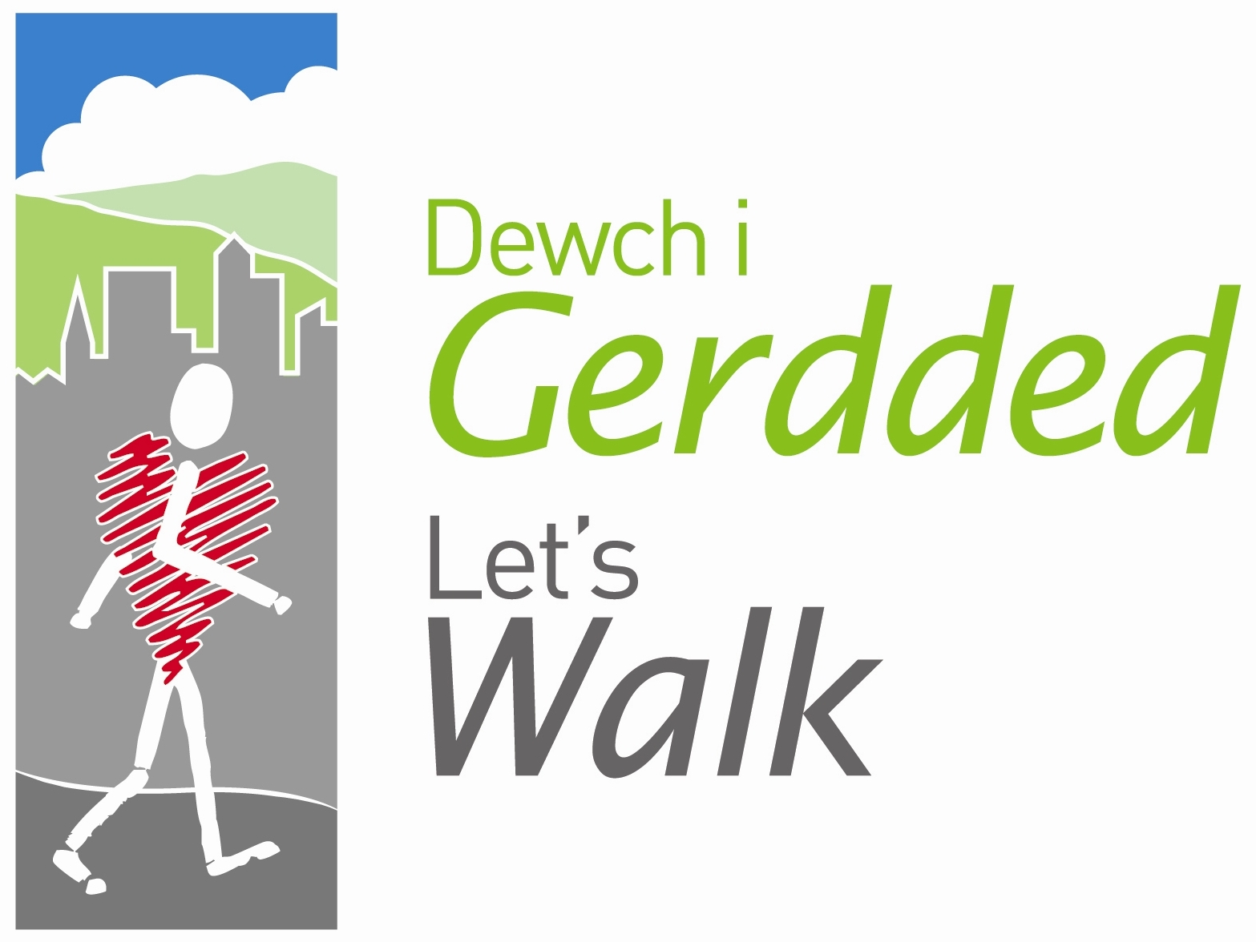
Risk Assessment Sheet

Date: ………………………………………………..…… Time: …………………..………………

Walk Location/route: ………………………………………………………….……………..…………………………

Assessment carried out by: ….………………………………………………………………………………………..

Hazard | Who might be harmed? | How is the risk controlled? | What further action is necessary to control the risk?

General comments: …………………………………………………………………………………………………………………………………………………………….……………..
………………………………………………………………………………………………………………………..………………………………………….………
……………………………………………………………………………………………………………………………………………………………………………

