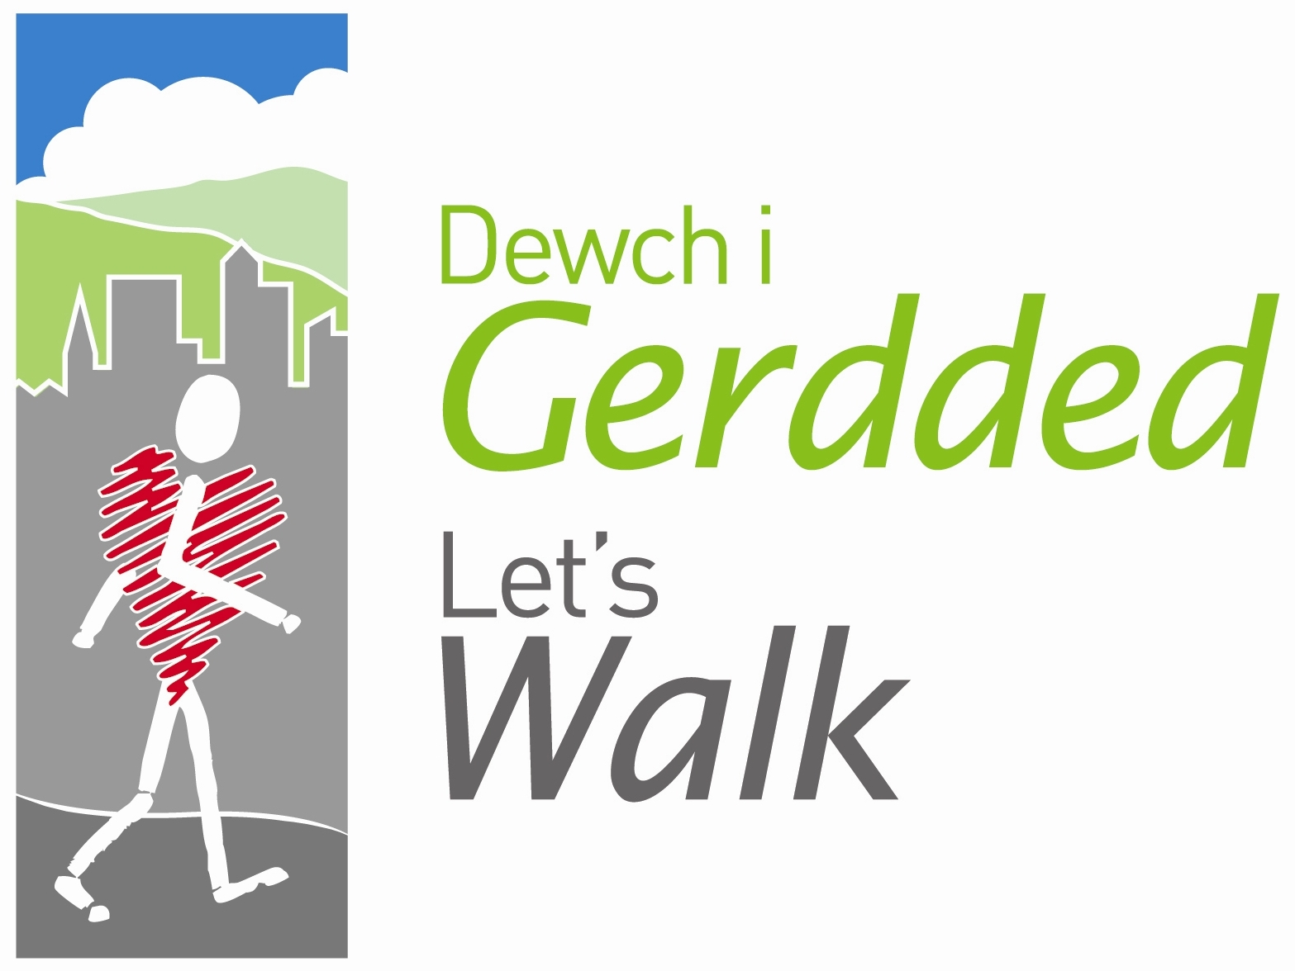
Walker’s Registration Form

Name of walk: …………………………………………………………

Please print your details (name and address).

Name: First name: ………………………….…..… Surname:…………………………………..........

Address:
House number/name: …………………………
Street: ……………………………………………………………………………………………………..
Town/City: ……………………………………… County: ...…………………………………………..
Postcode: ……………………………………… Tel no: ……………………………………………..
Email address: ……………………………………………………………………………………………
Age: 15-24  25-34  35-44 
45-54  55-64  65-74  75+ 

Gender: Male  Female 

Do you consider yourself to have a disability? Yes  No 

Ethnicity: White  Mixed  Chinese  Black/Black British 
Asian/Asian British  Other  (please specify) ……………………………….…
What is your first language? English  Welsh 
Other  (please specify) ……………………………….………
Where did you hear about this group? Friend/family member  Website  GP/Nurse recommendation  Poster/flier  Local event 
Other  (please specify) ……………………………………………………………………………
Are you a trained volunteer walk leader? Yes  No 
Would you like information about becoming a volunteer walk leader? Yes  No 

Please turn over

Physical Activity Levels

Please answer the following question as honestly as you can. Please be sure to read the question carefully.
In the past week, on how many days have you accumulated at least 30 minutes of moderate intensity physical activity as brisk walking, cycling, sport, exercise and active recreation?
(Do not include physical activity that may be part of your job or usual job activities).

Circle a number as appropriate

0 1 2 3 4 5 6 7 days

Using and sharing your information

Your information will be held by Let’s Walk Cymru (Ramblers Cymru) in accordance with the Data Protection Act 1998. It will also be used by your local scheme to evaluate their health walks programmes. The information will be collected by walk leaders and passed to the co-ordinator for inputting into a central database from which reports will be drawn for both the local and national programmes.

The information in this questionnaire will be kept confidential and will be anonymous when used.

Signed: ………………………………………………………………………………………………
Date: …………………………………………

Thank you for completing this form.

Please return it to your walk leader.

